
Course Physics
Laboratory Report

Experiment Title: Electromagnetic Oscillations

Name of student: Guliyeva Aychin
Group number: CE 22.2
Team number: 07

Experiment carried out: 31 March
Lab report submitted:7April

Supervisor: Associate Prof.G.Najafov

Synopsis
The report delves deeply into the dynamics of electromagnetic waves, beginning with an extensive examination of their basic principles and characteristics. It subsequently describes the experimental approach, encompassing the utilized equipment and methodologies for data gathering, with specific attention given to the phenomenon of damped oscillations. Furthermore, the report conducts a comprehensive analysis of the acquired data, particularly emphasizing measurements of oscillation periods, and explores the utilization of mathematical models to elucidate the behavior of electromagnetic waves, thus advancing comprehension in this field.

Introduction
Electromagnetic oscillations refer to the periodic changes occurring within the electromagnetic field, marked by the alternating presence of electric and magnetic fields traveling through space at the speed of light. These fluctuations arise when an alternating current (AC) is applied to an antenna, causing the electrons within the antenna to move back and forth, thereby producing electromagnetic waves.

Theory
In our experiment, we encountered a specific type of oscillation termed as damped oscillation, where the energy of an electromagnetic wave gradually diminishes over time. This phenomenon results in a decrease in the amplitude of the oscillation over time, along with potential changes in the frequency and wavelength of the wave due to damping. Within our experimental setup, we will perform manual calculations to determine the period using the provided equation:

T=t/N

Additionally, we can calculate the period using another equation:
T=2$π\sqrt{LC}$

Here, T represents the period, L signifies the inductance of the coil, and C denotes the capacitance of the capacitor. Finally, we will compare the values obtained from these two equations.
Top of Form

Set up
Before starting the experiment, we ensure that the system is completely discharged, beginning the oscillations from a state of zero. Additionally, the fluctuations in current can be directly monitored using CASSY.

Carrying out the experiment
Throughout the experiment, one team member will oversee the count of oscillations, while another will utilize a timer to record the elapsed time. Once the experiment is concluded, the outcomes, particularly the computed period values, will be compared and noted in the results table for further analysis.

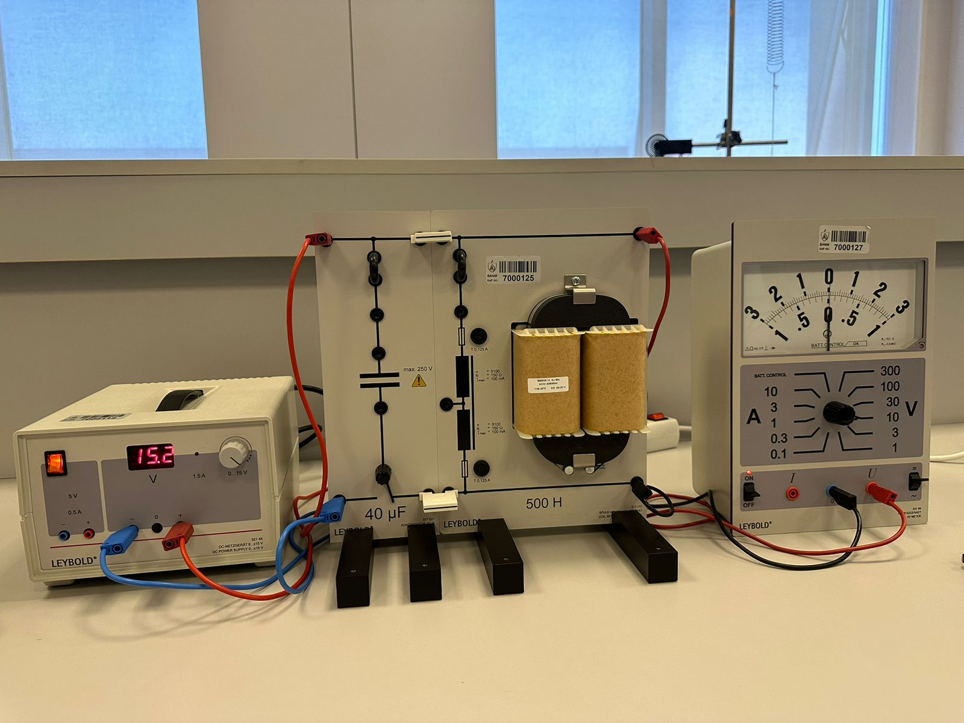

Results
№ | $$N$$ | $$t$$ | $$T_{N/t}$$ | $$T_{LC}$$
1 | 9 | 12 | 1.3 | 0.85
2 | 16 | 14 | 0.875 | 0.85
3 | 16 | 14 | 0.875 | 0.85

Discussion of result

The data provided presents a detailed analysis of the disparity between the period (T) values derived from two different equations. Despite encountering errors during our calculations, we engaged in thorough discussions with both our team members and supervisor to investigate the underlying reasons for this inconsistency. Through these collaborative efforts, we aimed to gain a holistic understanding of the factors influencing the deviation in our results, thereby facilitating the enhancement and refinement of our experimental techniques.

Conclusion
In summary, our project offered an intriguing investigation into electromagnetic oscillations, uncovering valuable insights through thorough analysis and teamwork. Despite facing hurdles, our collective work enhanced our comprehension of these phenomena and their real-world uses, emphasizing the significance of practical experimentation in scientific endeavors. In essence, this project expanded our understanding and emphasized the significance of electromagnetism in contemporary technology and communication systems.
Top of Form

References
Laboratory leaflets
BHOS Laboratory

